**EXPERIMENT 10**

**15BCE0517**

**M.S.SANJAY**

**1) Null Hypothesis- H0 : Preference for ice-cream is independent of gender**

**Alternate Hypothesis- H1 : Preference for ice-cream depends of gender**

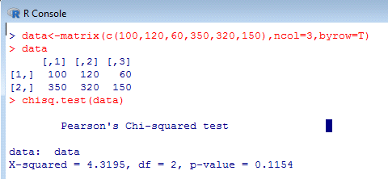

**Interpretation:-**

**Here p-value=0.1154 is greater than 0.05. Hence we accept the null hypothesis and conclude that there is no association between gender and preference of ice-cream**

**2)**

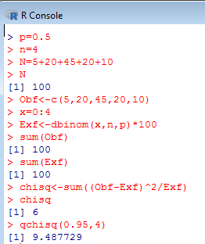

**Inference: Calculated value of chi-square is less than tabulated values, it is not significant at 5% level and hence the null hypothesis holds.**

**3)**

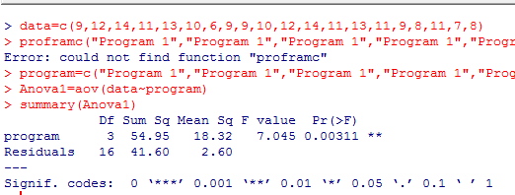

**Interpretation:**

**We can interpret the ANOVA table as since the p-value of 0.00311 is lesser than the significant level of 0.05 we can reject the null hypothesis that all 4 programs help perform tasks at the same level.**